Getting Our Feet Wet Lab
Complete the following lab individually and show your work to the instructor in person on or before the deadline. Your instructor will make time during the class to show your work in person. This lab has a lot of concepts packed into it and can take time due to the new tools and api that you are going to use. Start early to get adequate help. There are three problems on this lab. All of them must be completed to get credit for this lab. No email or late submissions will be accepted.
- Create and run an app in Android by following the directions at https://developer.android.com/training/basics/firstapp/creating-project.html

  - For Company Domain, instead of "example.com" use “edu.tacoma.uw.youruwnetid” (Mine is edu.tacoma.uw.mmuppa)
  - Use Java as the language as it defaults to Kotlin (Android proprietary language)
Complete all the way to creating another activity.
(My sample (myfirstapp.apk file) of this is available on canvas where this write up is. You have to drag and drop into the emulator to install and run it. If you are using an Android device, I found that uploading to the google drive and installing from there is the fastest approach.)

- Learn about the Android lifecycle at http://developer.android.com/training/basics/activity-lifecycle/index.html.
  - In both of the Activities created in Problem 1 above, correctly override all of the callback methods displayed in Figure 1.
  - Review the Logging capability in Android and the Log class.
    - In each of the overridden callback methods, add a call to one of the logging methods from the Log class.
      - Make sure you use one of each logging level:
      - d, i, w, v, and e

Here’s what my Logcat looks like on starting the MainActivity and clicking Send to launch DisplayMessageActivity, hitting back button to get back to MainActivity and then back button to the home screen.

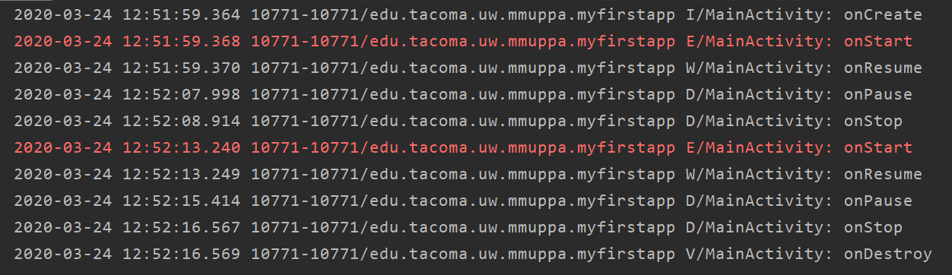

Here’s what it looks like with DisplayMessageActivity. The actions taken are launch MainActivity, click Send, Click Back on DisplayMessageActivity.
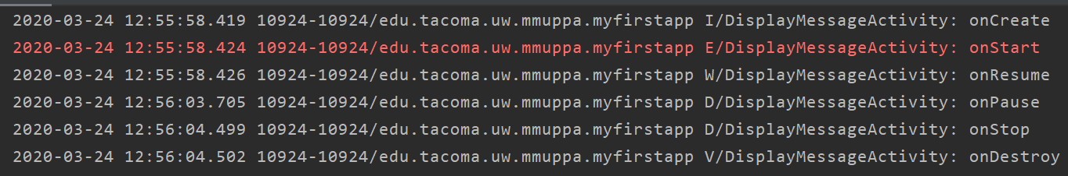
- Learn about some common Android Views and UI components. (My example (aboutme.apk file) of this is available on canvas where this write up is. You have to drag and drop into the emulator to install and run it. If you are using an Android device, I found that uploading to the google drive and installing from there is the fastest approach.)
  - Create a new App. If you are unsure how, refer to the steps defined in Problem 1)
    - Name the App: About Me
    - Company Domain: edu.tacoma.uw.youruwnetid
    - Minimum API: 16
  - The first Activity should display 5 buttons vertically down the center of the device screen. The text on the buttons is as follows:
    - Text
    - Image
    - Web
    - Toast
    - Dialog
  - The actions for each of the buttons is as follows:
    - Text
      - This button should open a new Activity.
      - In this activity, use at least 1 TextView to display some information about yourself. (Name, when you are graduating, do you have a job lined up, favorite class so far, etc.).
    - Image
      - This button should open a new Activity.
      - In this activity, use at least 1 ImageView to display an image(s) that best describe(s) you (Please keep the image appropriate). This should be a static image that you can set using attributes. Find an image and copy into the mipmap folder. Must BE ALL LOWERCASE.
    - Web
      - This button should open the following Web Page using implicit intent.
        - http://developer.android.com/index.html
    - Toast
      - This button should popup a Toast.
      - The text of the Toast is of your choosing.
    - Dialog
      - This button should popup a Dialog.
      - Build an AlertDialog to display some message. You may be creative on the message and use of the buttons on this dialog.

